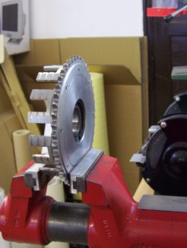

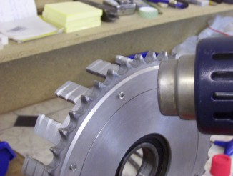
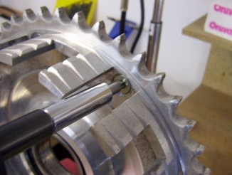

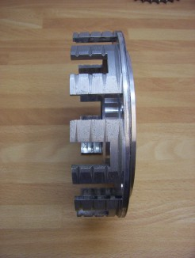
1) 2) 3)

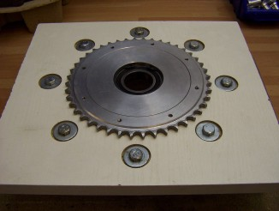
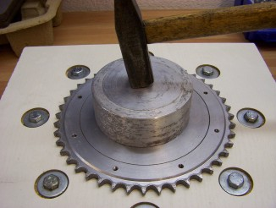
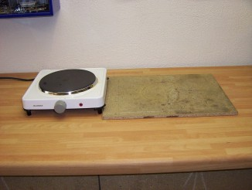
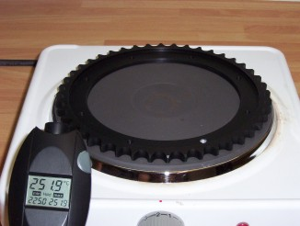
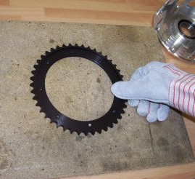
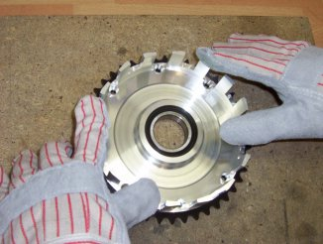
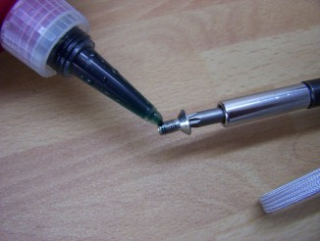
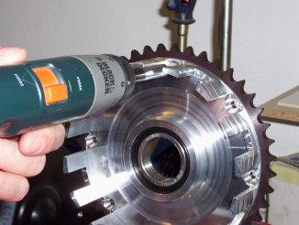
4) 5) 6) 7) 8) 9) 10) 11) 12)

1) Fix the clutch basket with the old sprocket in the vice.
2) By the hot air warm up the ends of the grub screws to achieve the release in the thread. (it is not always necessary).
3) Unscrew the grub screws.
4) Prop the clutch basket on the sprocket.
5) Place the ejector pin in the basket centre through which it will be driven out. The pin must be approximately 80 – 110 mm on average. Point the hammer stroke to the centre of the ejector pin in the way to avoid its dislocation. It is preferable to use the bigger hammer.
6) After the dismantling clean up the basket centre. Special attention must be paid to the contact surfaces of the basket and sprocket.
7) Prepare the working place for the new sprocket assembly (heating plate and heat-proof board).
8) Place the new sprocket on a 250-300°C pre-heated plate for 20-30 seconds. Warming up of the sprocket will lead to the enlargement of the pressing diameter from 1 to 2 mm.
9) Quickly move the heated sprocket on the assembly board.
10) Quickly move the basket centre on it. Provide the concentric position of the openings in the basket centre with the threads in the spocket by the even pressure on the basket centre. If you didn’t manage to achieve the right position of both parts - go back to step 4)
11) When sprocket is cooled down to the room temperature, put the highly-durable thread glue( for example, LOCTITE 2701) on the grub screw threads. The use of the new screws is recommended ( thread M6, length 10mm, sunk screw head with 60° angle and TORX 25 on spanner)
12) Those screws must be screwed-in to the spocket threads.

